|  |
| --- |
| Introducing Spelling Shed |

Spelling Shed is an online spelling platform designed by a team of Primary School teachers. It is built with primary school students, teachers and parents in mind and aims to make spelling fun and engaging for students.

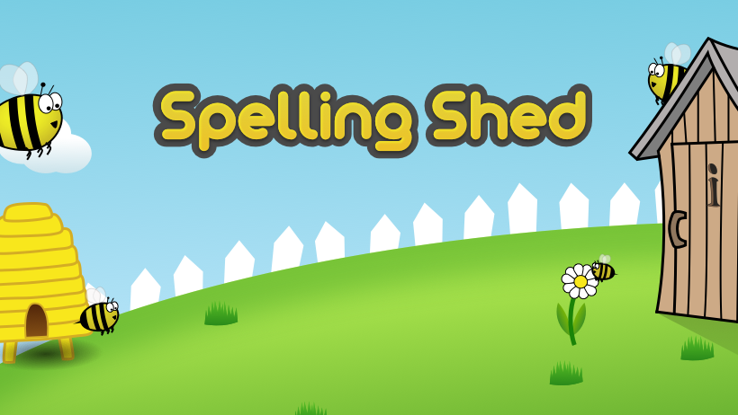

* Your child will receive their weekly spellings as an ‘Assignment’ via the ‘Spelling Shed’ app/website.
* Children will be able to access spellings via the ‘Spelling Shed’ app/online website.
* Children will be quizzed on their spellings each Friday.

**GAMES**

There are three kinds of game:

1. Practice – This is the main game type and used for assignments etc.
2. Bee Keeper – Can you guess your words by choosing letters?
3. Buzz Words – Make words using random letter tiles.

**Practice Games** have four difficulties:

* Easy – The word is shown, an audio clip is played and only the included letters are shown.
* Medium – An audio clip is played and only the included letters are shown.
* Hard – an audio clip is played and the included letters plus some random letters are shown.
* Extreme – An audio clip is played and a full qwerty keyboard is shown. Letters must be correctly accented and capitalised.

Higher levels allow a higher score to be achieved, but children can practise as much as they like on lower levels before trying to gain high scores.

Children will also have continuous access to their Key Stage common exception words.

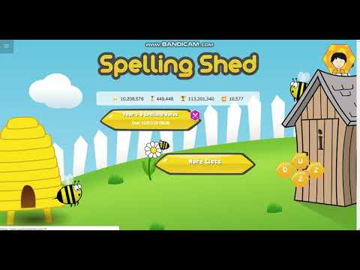Weekly assignment that will be tested the following **Friday.**

Continuous access to KS1/ KS2 common exception words to practice throughout the year.

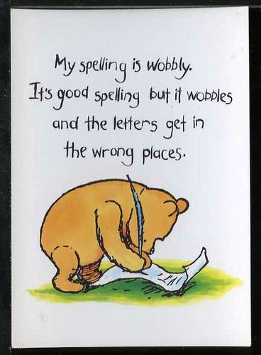‘Children who struggle with spelling usually have limited strategies up their sleeve when they get stuck on a word. Ask any weak spellers the question, “What do you do when you cannot spell a word?” They will have, at best, one strategy. But it is most likely that they guess. To help them become better spellers they need to acquire a range of different approaches to help them.’

Pie Corbett

**Approaches to use to support spellers.**

Use of phonics

Recognising words within words e.g. grand-mother, everywhere

Memory

Use of mnemonics: e.g. said – ‘Sally Ann is Dancing’

Reading, reading and more reading!

Regular practice